**Day 37:**

**Jenkin** : Jenkin is an open source CI and CD tools base upon Java technologies. Jenkin is plugin base and GUI base CI and CD tools.

Please visit below URL to download Jenkin war file

<https://www.jenkins.io/download/>

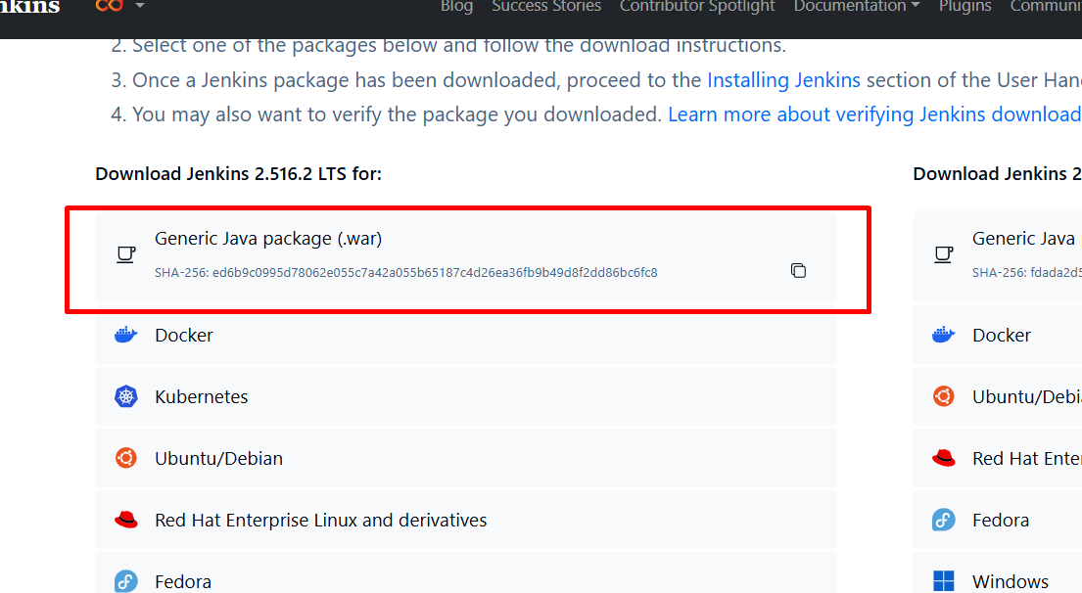

Running the Jenkin server using war file

java -jar jenkins.war (make sure command prompt open in the location war file present).

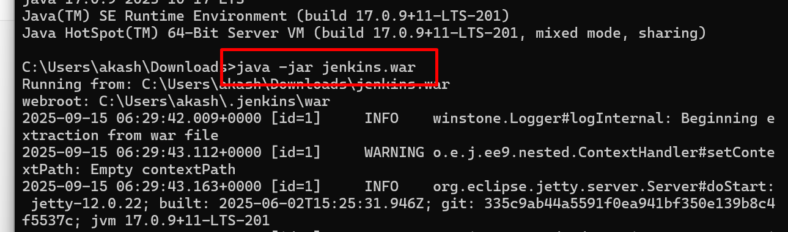

By default Jekin server run on port number 8080

java -jar jenkins.war --httpPort=9091

http://localhost:9091

it will ask you password first time.

password present in console terminal

after provided the password please select the option as install suggested plugin

after this will ask you to create the account.

Creating simple job to display echo message

Creating another job to execute ie compile and run the java program.

Creating job to build spring boot project with trigger option whenever use or developer push the code this job need to build the project

Jenkin Pipe line Job : Jenkin Pipe line job help use to execute sequence of task one by one

Testing : Testing is use to test the code working or not base upon client requirement. It is use to find bugs or error or defects.

Running the program without main function or main methods.

Testing mainly divided into 2 types.

1. Black box testing

Input Process Output

1. White box testing

Input Process Output

Unit testing : Unit testing is a type of white box testing which help to test smallest function functionality working or not.

Junit / TestNG

Nunit

Jasmine / Mocha / JEST :

jUnit is third party framework which provided set of classes and interface which help to test for Java Programs.